Assignment 5

Farida Aliyeva

## imports

import numpy as np

import pandas as pd

from sklearn import metrics##used to show the accuracy

from sklearn.metrics import confusion_matrix #used to describe performance of classifier

from sklearn.naive_bayes import MultinomialNB## Naive Bayes

from sklearn.metrics import classification_report##info abouve accuracy, precision and so on...

from sklearn.model_selection import train_test_split## allows us to split the given data

from sklearn.feature_extraction.text import CountVectorizer##converts text documents to matrix

Importing necessary libraries

## our data imported

info = pd.read_excel(r'C:\Users\ASUS\Desktop\python\azeri_news.xlsx',sep='\t',names=['Category','Title','news_article'])

Reading our excel file

info.head()## first rows from our data

Output:

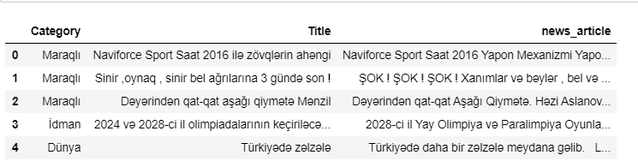

df_x=info["news_article"]

df_y=info["Category"]

##Count Vectorizer

vectorizer = CountVectorizer()

x_train, x_test, y_train, y_test = train_test_split(df_x, df_y, test_size=0.2, random_state=4)

x_train.head()

Output:

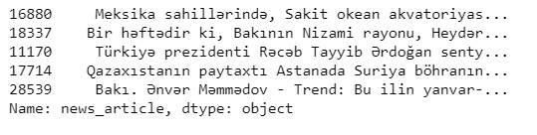

Here with the use of train test split library our scikit learn we split arrays of matrices into random train test subsets.

x_traincv = vectorizer.fit_transform(x_train)

vectorizer.get_feature_names()##feature names selected from documents

Output:

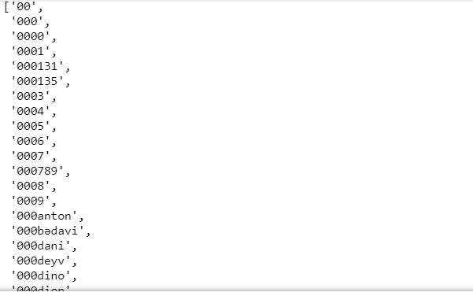The picture was cropped.

vectorizer.vocabulary_##mapping on the terms of indices of the features

Output:

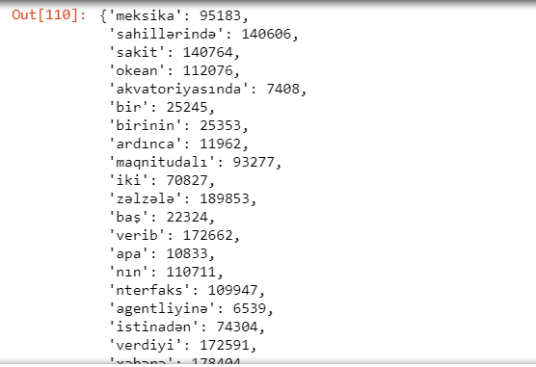The picture was cropped.

Now we Train a Naïve Bayes classifier on train dataset.

mnb = MultinomialNB()##Multinomial Naive Bayes

y_train=y_train.astype('str')

y_train

Output:

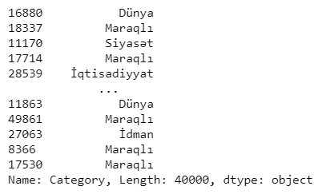

mnb.fit(x_traincv,y_train)



crosv_test = vectorizer.transform(x_test)

preds=mnb.predict(crosv_test)

preds

Output:



print("Accuracy:",metrics.accuracy_score(y_test,preds))

Output:



print(classification_report(y_test,preds))

Output:

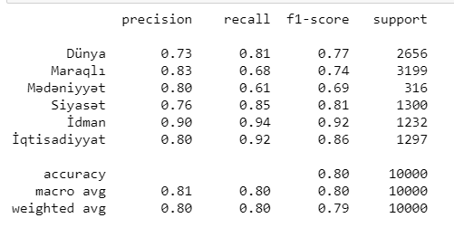

confusion_matrix(y_test, preds)

Output:

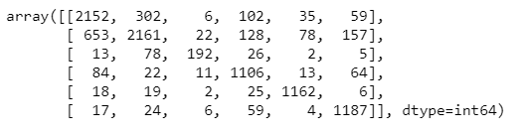

I also found 2 more vectorizers: Tfid and Hashing vectorizers. Hashing vectorizer didn’t work, there was a negative value error. However, Tfid vectorizer worked for our data. And here is the result:

## Now performing the same with TFID vectorizer

from sklearn.feature_extraction.text import TfidfVectorizer

ve = TfidfVectorizer()

x_traincv2 = ve.fit_transform(x_train)

mnb.fit(x_traincv2,y_train)

Output:



cv_t = vectorizer.transform(x_test)

predicts=mnb.predict(cv_t)

predicts

Output:



print("Accuracy:",metrics.accuracy_score(y_test,predicts))

Output:



print(classification_report(y_test,predicts))

Output:

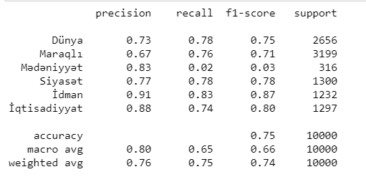

confusion_matrix(y_test, predicts)

Output:

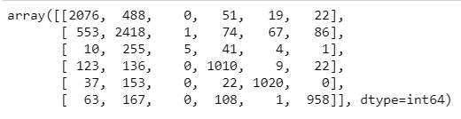

As we can see from the classification report, the accuracy is less with Tfid vectorizer than with the CountVectorizer.